Math 1435 – Area Practice Problems

1. What is the floor area of Bedroom #1 on the attached floor plan? Do not include the closet.
2. What is the floor area of bedroom #2 including the closet on the attached floor plan?
3. Find the overall square footage of the washroom that has the bath tub on the attached floor plan.
4. What is the overall square footage of the whole house on the attached floor plan?
5. Find the area of a circle with a radius of 3ft.
6. What is the area of the following shape?

2’-6”

Height

3’- 8”

Base

1. Find the area of the following shape.

77-1/4”

Over all

Height

Base

32”

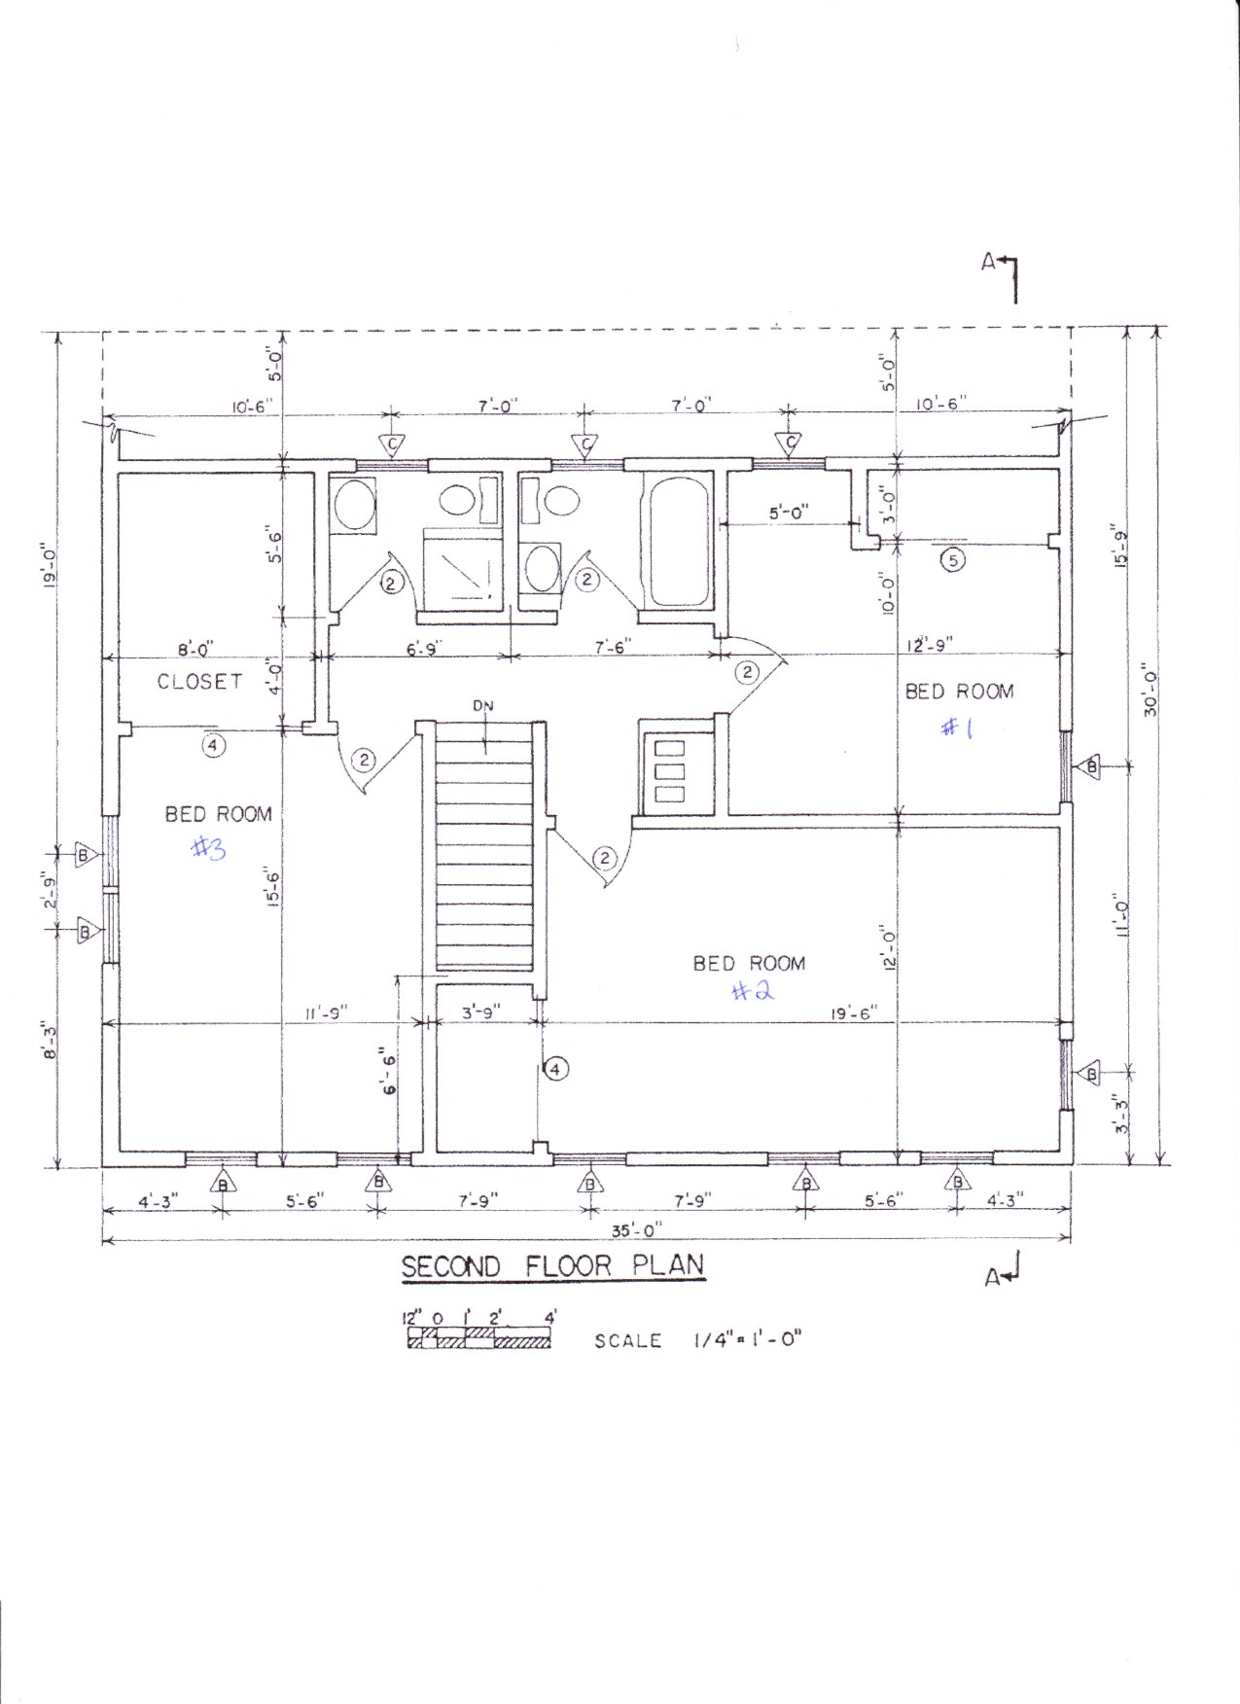

Math 1435 – Area Practice Problems

# Answer Key:

1. Total room – closet

=(13’x12’-9”)-((12’-9”-5’)x3)

=(13x12.75)-((12.75-5)x3)

=(165.75)-(7.75x3)

=165.75-23.25

**=142.5 sqft**

1. Bedroom + Closet

=(12’x19’-6”) + (6’-6”x3’-9”)

=(12x19.5) + (6.5x3.75)

=234+24.375

**=258.375 sqft**

1. Bathroom

=7’-6”x5’-6”

=7.5x5.5

=**41.25 sqft**

1. Length x width

=(35’)x(12’+10’+3’)

=35x25

=**875 sqft**

$A=πr^{2}$

= 3.141592654 x 3²

=3.141592654x9

=**28.27433388 sqft**

$A=\frac{base x height}{2}$

= $\frac{3^{'}-8" x 2'-6"}{2}$

= $\frac{3.6666x2.5}{2}$

=**4.5833 sqft (rounded)**

1. A=( $\frac{base x height(1 triangle)}{2}$)x number of triangles

= $\left(\frac{32x38.625}{2}\right)x 8$

=618x8

=**4,944 inches²**